**THE DESIGN AND DEVELOPMENT OF LIVESTOCK MARKET SYSTEM: A CASE STUDY OF ARUA, WESTNILE, UGANDA.**

_____________________

A Project Report

Presented to the Faculty of Techno science

Muni University Arua,

Uganda

__________________

In Partial Fulfillment of the Requirements for the Degree of

Bachelor of Information Systems

________________

**BY**

NAGAWA DOROTH 2017/U/ISM/015/G

NYANZI SHAFIK 2017/U/ISM/017/G

NAGIMESI WYCLIFE 2017/U/ISM/016/G

ATUGONZA GAMUKAMA 2017/U/ISM/005/G

BALYEJUSA MACHAEL 2017/U/ISM/006/G

# 

# **DECLARATION**

We hereby declare that this Project report is original and has not been published and/or submitted for any other Degree award to any other University before.

**1SM C GROUP MEMBERS**

|  |  |  |
| --- | --- | --- |
| **STUDENT NAME** | **REG NUMBER** | **SIGNATURE** |
|  |  |  |
| NAGAWA DOROTH | 2017/U/ISM/015/G | ……………….. |
|  |  |  |
| NYANZI SHAFIK | 2017/U/ISM/017/G | ……………….. |
|  |  |  |
| NAGIMESI WYCLIFE | 2017/U/ISM/016/G | ……………........ |
|  |  |  |
| ATUGONZA GAMUKAMA | 2017/U/ISM/005./G | ………………… |
|  |  |  |
| BALYEJUSA MICHAEL | 2017/U/ISM/006/G | …………………. |
|  |  |  |
|  |  |  |

# **APPROVAL**

All the work in this project report as a partial fulfillment for the award of a Bachelors’ degree in Information Systems in Muni University has been done under the supervision of the University supervisor. We therefore submit this project after approval from the University supervisor.

Ms. MUKIMBA FIONA

Signature: …………………………………. Date: …………………………….

# **ACKNOWLEDGEMENT**

We express our sincere thanks to the Almighty God for the gift of life and making us able to complete this project.

We would like also to thank our University supervisor Ms. Mukimba Fiona for the good work done towards the completion of this project.

In a special way we also thank our dear parents, siblings and friends for their tremendous support rendered towards the completion of this project, we pray that the Almighty God rewards them abundantly.

# **TABLE OF CONTENT**

**Contents**

**DECLARATION** i

**APPROVAL** ii

**ACKNOWLEDGEMENT** iii

**TABLE OF CONTENT** iv

**LIST OF TABLES** vii

**LIST OF FIGURES** viii

**Table of ACRONYMS** ix

**ABSTRACT** x

**CHAPTER ONE: INTRODUCTION** 1

**1.0 Introduction** 1

1.1 Background of the Study 1

1.2 Statement of the Problem 6

1.4 Objectives 6

1.4.1 General objective. 6

1.4.2 Specific Objectives 6

1.4.3 Research Questions 7

1.5.4 Scope of the study. 7

1.4 Significance of the Study. 7

**CHAPTER TWO: LITERATURE REVIEW** 8

**2.1 Introduction** 8

2.2 Review of Related Literature 8

**2.2.1 Livestock Production** 9

**2.2.2 IT as a Tool for Marketing** 9

**2.2.3 Challenges in the above literature** 10

2.3 Gaps Identified in related Studies 10

**CHAPTER THREE: METHODOLOGIES** 11

**3.1 Introduction** 11

3.2 Research Design 11

3.2.1 Population 11

3.2.2 Sampling 11

3.2.2.1 Data collection 12

3.2.2.2 Data analysis 12

3.3 Design Methodology 13

3.3.1. Hypothesis 13

3.4 Requirement specification 13

3.4.1 Hardware requirements 13

3.4.3 Software requirements 13

3.4.4 Functional requirements 14

3.4.5 Non-functional requirements 14

**CHAPTER FOUR: SYSTEM DESIGN AND IMPLEMENTATION** 15

**4.1 INTRODUCTION** 15

4.2 System Design. 15

4.2.1 Process Design 15

4.2.1.4 Sequence diagram. 18

4.2.1.5 Database Design. 19

4.2.1.6 Entity Relationship Diagram 20

4.2.1.7 Data Flow Diagram (DFD). 21

4.2.1.8 Object class diagram. 24

4.2.1.9 Interface Design. 24

4.3 System Implementation 26

CHAPTER FIVE: SYSTEM TESTING AND EVALUATION 27

5.1 Introduction 27

5.2 System Testing. 27

5.2.1 System Verification. 28

5.2.2 System Validation. 28

5.3 System Evaluation. 28

CHAPTER SIX: ETHICAL CONSIDERATIONS AND LIMITATIONS 29

6.1 Introduction. 29

6.2 Ethical Considerations 29

6.2.1 Human ethical consideration. 29

6.2.2 System ethical considerations. 29

6.3 Limitations of the project. 30

CHAPTER SEVEN: CONCLUSION AND RECOMMENDATION 31

7.1 Introduction 31

7.2 Conclusions 31

7.4 Recommendations 31

REFERENCES 32

Appendix I - Research Instrument 33

# LIST OF TABLES

Table 1: shows hardware requirements of an online livestock market system 23

Table 2: shows software requirements of an online livestock market system 24

# **LIST OF FIGURES**

Figure 1: shows livestock production in Uganda 11

Figure 2: above shows livestock numbers (’000) from 2009 to 2012.source UBOS 2013 13

Figure 3: shows a use case diagram of an online livestock management system 26

Figure 4: A state diagram for a livestock market system. 27

Figure 5: Shows a sequence diagram for a livestock market system 28

Figure 6: shows database table designs of an online livestock market system 29

Figure 7: shows ERD diagram for an online livestock market system 30

Figure 8: shows extended ERD diagram for an online livestock market system 31

Figure 9; shows the DFD Level 0 31

Figure 10; SHOWS DFD LEVEL 1 32

Figure 11:Shows Data Flow Diagram Level 2 of a livestock management system 33

Figure 12:Shows the Object Class diagram for a livestock market system 34

Figure 13 shows cart page interface 36

# **Table of ACRONYMS**

|  |  |  |
| --- | --- | --- |
| No. | **ABBREVIATION** | **ACRONYMS** |
| 1 | AFARD | Africa Institute for Strategic Animal Resource Services and Development |
| 2. | GDP | Gross Domestic Product |
| 3. | US | United States |
| 4. | MAAIF | Ministry of Agriculture, Animal Industry and Fisheries |
| 5. | HTML | Hyper Text Mark Language |
| 6. | CSS | Cascading style sheet |
| 7. | AFRISA | Africa institute for Strategic Animal Resource Services and Development |
| 8. | CAADP | Comprehensive Africa Agricultural Development Programme |
| 9. | PHP | Hypertext Preprocessor |
| 10. | NEPAD | New Partnership for Africa’s Development |
| 11. | NGO | Non-Governmental Organizations |
| 12. | SSA | Sub Saharan Africa |
| 13. | SRS | Simple Random Sampling |
| 14. | NARO | National Agriculture Research and Development Institute. |

# 

# **ABSTRACT**

This project report examined livestock market in West Nile, which is one of the least developed region characterized by recurrent drought, inadequate basic livestock market infrastructure and accessibility. The design and implementation of an online livestock market for livestock products and live animals and birds to enable farmers market their products more efficiently at reduced costs, ease access to information about disease prevention, livestock incentives, quality breeds and market opportunities. This can be achieved through the designed and implemented online livestock market system that can enable farmers market their livestock and livestock products online at reduced costs, get access to wider customer base, market livestock, livestock products anywhere anytime.

# 

# **CHAPTER ONE: INTRODUCTION**

# **1.0 Introduction**

This chapter mainly covers the background of the study (history, concept, and context), Statement of the problem, objectives of the study (main objectives, specific objectives, and research questions), scope (content, geographical, and time scope) and significance of the study.

## Background of the Study

Livestock is defined as domesticated animals raised in an agricultural setting to produce labor and commodities such as meat, eggs, milk, fur, leather, and wool. The term is sometimes used to refer solely to those that are bred for consumption, while other times it refers only to farmed ruminants, such as cattle and goats, horses. Livestock are an integral part of agriculture in most The Ministry plans to create more forums as a solution where farmers can access information on cattle breeds, feed production and animal husbandry practices to increase the contribution of livestock to the national GDP, currently standing at 12%. The livestock sector is one of Uganda’s important growth sectors contributing about US $ 290 million to total GDP in 2008/09 up from US $ 210 million in 2007/08. It constitutes 17 percent of the agricultural GDP and is a source of livelihood to about 4.5 million people in the country .The growing local and regional demand for meat and milk products has escalated the number of livestock in the country over the years to an estimated 68 million in 2008 compared with about 49 million livestock in 2002. the 2008 national livestock census estimated the number of cattle at 11.4 million whereas the sheep, goats, pigs and poultry were estimated at 3.4 million, 8.5 million, 3.2 million and about 27.5 million respectively (MAAIF, 2009).

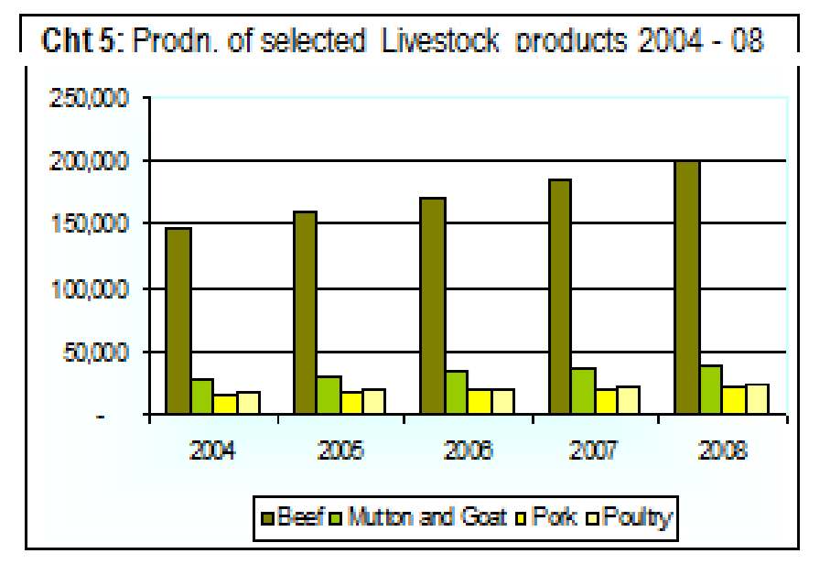

Figure 1: shows livestock production in Uganda

In economic value, cattle are considered the most important livestock although other animals such as goats, sheep, pigs and poultry are equally important. Uganda’s cattle corridor extends from the south western, through central to the north eastern region (Chart 1). 93.6 percent of Uganda’s cattle herds are indigenous; - Ankole (29.6%) and Zebu/Nganda (70.4%), whereas 0.8% are beef exotic/cross breeds and; 5.6% are dairy exotic/cross breeds. In terms of distribution, the eastern region (23%), Karamojong (20%) and central region (19%) have the highest number of cattle followed by the south western (16%).

Livestock production constitutes an important subsector of Uganda’s agriculture, contributing about 9 per cent of Gross Domestic Product and 17 per cent of Agricultural Gross Domestic Product and is a source of livelihood to about 4.5million people in the country (UIA, 2009). In economic value, cattle are considered the most important livestock although other animals such as goats, sheep, pigs and poultry are equally important. Cattle are the main source of meat in the country and are reared on rangelands which occupy 84 000 km².

The greatest concentration of livestock is found in the "cattle corridor", extending from Southwestern to North Eastern Uganda. This corridor covers the districts of Ntungamo, Mbarara, Mpigi, Kiboga, Luwero, Apac, Lira, Soroti, Kumi, Mbale, Moroto, and Kotido (INFOTRADE, 2011). Most of the beef production is the done on extensive production systems mainly located in the cattle corridor system in Central Uganda.

The livestock sector is governed by several policies and regulations including the national delivery of veterinary services, national veterinary drug policy, national hides, skins and leather

policy, animal breeding policy and the animal feeds policy among others. The recently enacted Meat Industry development law was instituted to improve production, processing and marketing. of meat and meat products.(UGANDA INVESTMENT REPORT AUTHORITY AGRICULTURE BEEF, 2011)

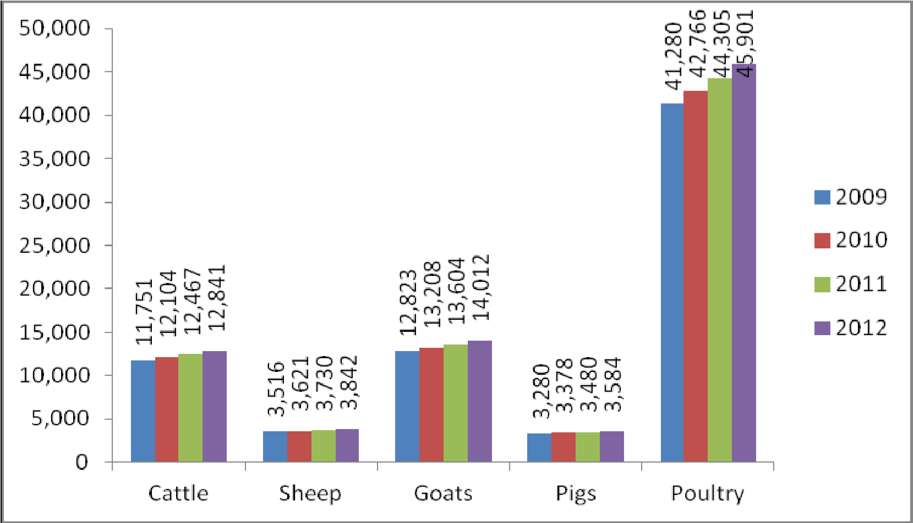

Figure 2: above shows livestock numbers (’000) from 2009 to 2012.souce UBOS 2013

Poultry

Local chicken was the main poultry species reared among others like turkeys, ducks, Guinea Fowls, geese and pigeons. This was mainly kept on free range system. In the peri-urban and urban areas of Arua, Moyo and Nebbi exotic breeds were commercially reared. The challenge was in acquiring inputs like day old chicks and feeds which were all purchased from Kampala. There was a lot of phobia about exotic breeds of chicken amongst farmers and also extension staff citing high losses due to mortalities. Farmers also expressed the high labor needs of the enterprise especially in management of day old chicks as backed by a voice below: “These birds need water, warmth, you have to be there and they eat a lot, when you have them it’s like another baby!” female respondent Yumbe. Previous attempts by individual farmers, government programmes and NGO’s to introduce exotic breeds of chicken have had major setbacks due to high mortalities, high cost and poor quality feeds and low market for broiler birds.

Broilers were perceived to have soft meat which the population did not appreciate hence the only market was a few hotels (where its deep fried) in the region. Layers can be promoted because the demand for eggs within the region and neighboring countries exceed the current production. Local chicken production is economically viable since the prices were very attractive, local cock was 20,000-25,000/= as compared to a broiler at 8,000-10,000/=

Apiary

The West Nile region has been identified as the best honey-producing region and produces up to three quarters of honey in Uganda (Acai et al, 2010). Both modern (KTB & Lang troth) and traditional beehives (Log hives) are used for bee rearing (plate 6), characterized by low colonization rates and high rate of absconding. The modern beehives have been reported to be very expensive in all the districts visited despite efforts by NAADS to promote them.

Yumbe District is the highest producer of honey in Uganda. As per the 2008 livestock census (UBOS, 2009) the district was reported to have produced 129,950 Kgs of honey. The district that comes next to Yumbe district in honey production in West Nile includes Maracha (43,950 kg) and Nebbi (42,620 kg).

Dairy cattle Production

Zombo district has the greatest potential in dairy production however selected areas in Arua and Nebbi districts can also support the enterprise. In Arua district the areas suitable for dairy production include; Vurra Sub county (S/C) which has high rainfall and good vegetation cover, Logiri S/C, Eceko parish in Arivu S/C (have vast land),good pasture density) and receives relatively high rainfall. In Nebbi, Erusi s/c and Goli parish in Nebbi S/C have equally good climate that can promote exotic dairy farming.

Small ruminants (Goats and Sheep)

The good vegetation cover and vast rangeland along the Nile belt favors small ruminant production in West Nile. Being drought resilient, small ruminants can thrive in areas of limited water supply as is the case during dry season in most parts of West Nile. Currently small ruminants are mainly raised through tethering at subsistence level especially in nucleus human settlements and fragmented land where crop farming is the primary activity. Communities mainly keep local breeds of goats and sheep. Some attempts have been made through NGO’s which include AAH,AFARD, GTZ,PARUDA (Participatory Rural Development Agency), CARITAS, Send a Cow Uganda, DRC (Danish Refugee Council) among others and Government programmes like

NAADS to improve the local goats by cross breeding with boar, Mubende, Toggenburg and

Saanen. However, the challenges that have negatively affected goat improvement efforts as reported by key informants and farmers were high mortality of adult exotic goats and low kid survival rates.

Micro-livestock such as Rabbit and Guinea Pigs are kept by very few individuals for household consumption although some are sold for income. Although the above livestock were not popular, their small space requirements ease of rearing and wide range of forage makes them cheaper source of animal proteins. They can therefore be promoted for addressing malnutrition related to animal protein deficiency in poor households that cannot afford conventional (beef, goat and pork) meat. of Uganda; production systems have evolved over time to suit the agro ecological zones and the socio-economic setting income for the majority of the smallholder farmers living in the rural areas. functions. They also sustain employment and genetic resources involves carrying out baseline surveys in order to establish identities and characteristics of individual populations (breeds/strains); determine the status of animal populations; and document the existing production and management systems.  Livestock and livestock product marketing systems involves selling of livestock and livestock products such as hides, skin, ghee among others to the customers in addition to providing of necessary information to farmers that will help them boost livestock sector. However the livestock sector is faced by the problems such as diseases, harsh climatic conditions, poor quality breeds among others.

Research Report published in July 2017, it says; The Sheep and Cattle Farming industry in China consists of farms engaged in the feeding of sheep, cattle, horses, mules, donkeys, camels and other major livestock Not only the countries mentioned above but also Uganda carries out livestock farming. In a profile released by Sandra she says; however, at Arua, West Nile, the farmers face different challenges for example; climatic changes, poor cattle breeds, inadequate veterinary services and low market for both milk and beef. The farmers have devised different measures in order to cub the challenges that is do sell their products in a mixed market where they are highly charged, move long distances and incur high transport costs for example one of the farmers we interviewed pays a lot of transport to the market to sell off his livestock products.(*Livestock Development Needs Assessment Report for*, n.d. AFARD-

AFRISA report MAY 2012)

According to the current trend in Agriculture and Information Technology, we have seen an evolution in the development of systems which will help farmers to solve quite a good number of problems. Establishment of an online livestock market for livestock farmers will significantly reduce their challenges faced during the selling off of their livestock and livestock products.

## Statement of the Problem

Marketing of livestock and livestock products in west Nile is affected by limited access to customers, high transportation costs, long distances to market places, limited fixed working hours, high amounts of money charged for selling of livestock and livestock products which leads to low profits by farmers leading to low-incomes to livestock farmers hence high poverty rates and low standards of living. Therefore the design and development of an online livestock market will boost sales and increase profits for livestock and livestock products thus increasing farmers’ income levels thus better standards of living **(Livestock Development Needs Assessment Report for, n.d. AFARD-AFRISA report MAY 2012).**

## 1.4 Objectives

This identifies the general objectives of the study, specific objectives of the study.

## 1.4.1 General objective.

The general objective of the study was to design and develop an online livestock market which willincrease market accessibility for livestock and livestock products as well as enable access to modern livestock farming techniques by farmers hence enhancing livestock productivity in West Nile and the whole economy at large.

## 1.4.2 Specific Objectives

1. To analyze the functional requirements and end user needs of the system and come up with the software requirement specification.
2. To implement an online livestock market as per the design document specification using python.
3. To design a detailed product architecture based on the software requirement specification.
4. To test and deploy the developed online livestock market to enable the farmers market their products.

## 1.4.3 Research Questions

1. What are the functional requirements an online livestock market should have?
2. What are the information needs of Arua, West Nile livestock farmers?
3. What effective methodology can be used to design the proposed livestock and livestock products market system?
4. How will the developed system be tested?
5. How can an online livestock market be designed to sufficiently serve the information needs of West Nile farmers?
6. What features will be used to compare the developed system against other developed systems?
7. Which software analysis and design tools and techniques are most suitable for developing an online livestock market for Farmers in Arua West Nile?

## 1.5.4 Scope of the study.

The livestock and livestock Market System should be able to register Farmer and customers on system so that the farmers can be able to upload products and customers will be able to view and purchase then.

## Significance of the Study.

Marketing of livestock and livestock products in west Nile is affected by limited access to customers, high transportation costs, long distances to market places, limited fixed working hours, high amounts of money charged for selling of livestock and livestock products which leads to low profits by farmers leading to low-incomes to livestock farmers hence high poverty rates and low standards of living. We have seen a need to develop a web application that will aid farmers to market their products through providing them access to a wide customer base, provide flexible working hours, reduce transportation costs for product increasing profits and thus improving their standards of living and the economy.

# **CHAPTER TWO: LITERATURE REVIEW**

# **2.1 Introduction**

This chapter covers information concerning review and analysis of related studies of insurance management system developed by other scholars before. It will also involve identifying the gaps in those studies that our research will cover.

This chapter explains the critical review and analysis of relevant studies that have been done by other scholars in our specific area of interest with a view of identifying the gaps in those studies that our research covered.

## 2.2 Review of Related Literature

According to AFARD-AFRISA partnership report about the livestock development needs assessment report for west Nile region;

Livestock serve many purposes in the livelihoods of rural communities in Africa namely: household source of income, Investment, food, manure, draught power, raw materials, and bride price. These gains are crucial potential pathway out of poverty for rural producers and other actors along the marketing chain. Raising the subsector’s value chain Productivity and efficiency as enshrined in the Comprehensive Africa Agricultural Development Programme (CAADP) of the New Partnership for Africa’s Development (NEPAD) is considered essential to the success of Sub Saharan Africa (SSA) rural economies and growth of incomes of rural populations.

The ingenuity of this model has called on AFARD to partner with AFRISA to promote livestock production in the West Nile region. Some anecdotal data from AFARD revealed that there was no significant increase in livestock population and incomes in the region due to a number of factors: poor breeds, livestock diseases, and traditional management practices. The transformation of these inherent age-long impediments to livestock production as a business required this needs assessment. The objectives of the assessment were to: profile the livestock enterprises and their capacities in the AFARD operation areas; establish the constraints in livestock keeping; map out opportunities for livestock development in the areas; and propose market-oriented targeted interventions.

From the above analysis, transforming livestock farming into a business in West Nile region is feasible. Vast opportunities exist to promote this transformation. What farmers need is the change of their constraining subsistence attitude through relevant knowledge and skills training for livestock keeping as a business? Achieving this will require strategic and innovative approach that is based on market-driven focus rather than the common charity based support by NGO’s and government programmes.

Livestock marketing is a very essential activity in every society, however it is on a very small scale in west Nile region which is mainly done by sole farmers in the markets of Odromacheku.

According to West Nile web findings below is an example of limited livestock; Mrs. Eunice Baiti, 21, says they prefer to resell to Congolese traders because Ugandan buyers only look for small goats mainly to pay dowry. On the other hand when the middlemen buy items such as groundnuts and apparels from Congolese traders they resell to Ugandan customers. Other major agricultural commodities traded at Odromachaku include cattle, pigs, cassava flour, millet, beans and sorghum while manufactured goods include bicycle spare parts, clothes and cooking utensils among others.

# **2.2.1 Livestock Production**

The inadequate market of livestock, livestock products, the poor livestock breeds and livestock diseases. This has been due to the poor marketing strategies and ignorance of farmers of modern techniques of livestock farming. We have seen a need to develop a web application that will aid farmers to market their products and equip them with the modern farming techniques which will improve livestock production thus improving their standards of living and the economy.

# **2.2.2 IT as a Tool for Marketing**

IT is becoming increasingly used as a marketing tool country wide, some of the available marketing companies include Jumia online shopping company which deals in electronics and home accessories, Kikuubo online shopping which deals in stationary, home accessories and restaurant among other dealings, OLX group is an online market operating in 45 countries as a platform for buying and selling of services and goods such as electronics, fashion items, furniture, household goods, cars and bikes.

Social platforms such as Facebook, WhatsApp, LinkedIn, Instagram, twitter are also used as marketing tools since they are accessed by many people.

# **2.2.3 Challenges in the above literature**

All the above marketing platforms do not offer a flexible means of payment that is they only offer mobile money without catering for bank payments. They do some little marketing of a few livestock products, but do not give priority to fully exhaust the full potential of livestock farmers in Uganda, and yet livestock production increases exponentially with time as the main source of income for low income earners. Lack of strong features to convert non-internet users as potential clients.

## 2.3 Gaps Identified in related Studies

1. All the above stated marketing platforms in the literature review do not offer a flexible means of payment that is they only offer mobile money without catering for bank payments. They do some little marketing of a few livestock products, but do not give priority to fully exhaust the full potential of livestock farmers in Uganda, and yet livestock production increases exponentially with time as the main source of income for low income earners. Lack of strong features to convert non-internet users as potential clients. Participation rates are markedly for older individuals, people with low levels of Education as wells as low income households and those in rural areas (OECD Unpacking E-Commerce May, 2019).
2. In the literature review, online marketing companies such as Jumia, OXL, Kikubo deal in electronics, home accessories, clothing’s, stationeries, there is little emphasis on online marketing of livestock, livestock products and yet the population of goats , sheep, pig, poultry numbers increased by 1.97%, 3.20%, 0.54% and 2.78% respectively between 2016 and 2017(UBOS 2018 Statistical Abstract).

# **CHAPTER THREE: METHODOLOGIES**

# **3.1 Introduction**

This chapter covers the methodology that we used to conduct the study. These include the project design (target population, sample and sampling procedure). Besides, this section also contains data collection instruments, data collection procedures, methods of data analysis, operational definition of variables, tools to be used for development and ethical issues.

## 3.2 Research Design

Research design refers to a set of methods and procedures used in collecting and analyzing measures of variables specified in the problem research. Research design is the blue print of the research process.

### 3.2.1 Population

Population is the entire group of people or objects to which the researcher wishes to  
generalize the study findings (Best, 2006).A population refers to a complete set of objects, cases, and individuals that the researchers intend to generalize the research results to (Olive & Abel, 1999).

The population for this project was the livestock farmers in Arua district, West Nile region and Arua, West Nile was our specified case study.

### 3.2.2 Sampling

A sample is a finite part of a statistical population whose properties are studied to gain information about the whole (Webster, 1985). Sampling is the process of selecting a few (a sample) from a bigger group (the sampling population) to become the basis of estimating or predicting a fact, a situation or outcome regarding the bigger group (Kumar, 2005, p. 148).

The sampling technique which we used to select a sample was Simple Random Sampling (SRS). Simple Random Sampling is the most basic scheme of random sampling.

Steps followed in simple random sampling include;

Making a numbered list of all the units in the population from which you want to draw a sample. Each unit on the list was numbered in sequence from 1 to N (where N is the size of the population).

1. Decide on the size of sample.
2. Select the required number of sampling units, using a “fishbowl” draw or a computer program.

After the use of SRS, we selected a sample known as Arua, West Nile.

Arua, West Nile was our case study that we sampled and we collected data from the various farmers within Arua as well as the management of the of the ABI FARM through oral interviews, document reviews, and questionnaire. The information was provided by management and other livestock farmers in Arua helped us in identifying both the functional and non-functional requirements of the proposed system. The casual workers at the farm who had livestock in their homes were also interviewed.

## 3.2.2.1 Data collection

This is the process of gathering and measuring information on variables of interest, in an established systematic fashion that enables one to answer stated research questions, test hypotheses, and evaluate outcomes. We collected data using a questionnaire, interview guide to conduct Oral interviews which we used by administering them to the respondents in Arua West Nile to acquire all the necessary information for the design and implementation of the online livestock market system. Number of questionnaires issued was 30 interviewed 10 livestock farmers in Arua.

## 3.2.2.2 Data analysis

This is the process of systematically applying statistical and/or logical techniques to describe and illustrate, condense and recap, and evaluate data. An essential component of ensuring data integrity is the accurate and appropriate analysis of research findings. We used SPSS to analyze all the data that we collected from the field access the validity and reliability for the need to design and implement of online livestock market system and the following were our statistical analysis and findings;

## 3.3 Design Methodology

The system is designed using Incremental Model of Agile development. Incremental model is where the software is developed in increments with the customer specifying the requirements to be included in each increment. This results in small incremental releases with each release building on previous functionality. Each release is thoroughly tested to ensure software quality is maintained.

The project team employed a top-down approach of system design in which the system was broken down into compositional subsystems. Each subsystem was then tested and refined into greater detail.

# 3.3.1. Hypothesis

Basing on the hypothesis is that, “there is limited access to customers and therefore limited market for livestock products.” We used deductive approach, we carried out a quantitative research for the above hypothesis to prove its validity.

## 3.4 Requirement specification

Requirements specification is the process of writing down the user and system requirements in a requirements document. The user and system requirements should be clear, unambiguous, easy to understand, complete, and consistent. Requirements for a software system set out what the system should do and define constraints on its operation and implementation. (Ian Summerville, 2017)

# 3.4.1 Hardware requirements

|  |  |
| --- | --- |
| **Number** | **REQUIREMENT AND ITS QUALITIES** |
| 1 | A working Computer 2gb RAM |

Table 1: shows hardware requirements of an online livestock market system

## 3.4.3 Software requirements

|  |  |
| --- | --- |
| Number | **Requirement** |
| 1 | HTML |
| 2 | Django |
| 3 | CSS |
| 4 | JavaScript |
| 5 | Python |

Table 2: shows software requirements of an online livestock market system

## 3.4.4 Functional requirements

Functional requirements are statements of the services that the system must provide or are descriptions of how some computations must be carried out. (Ian Summerville, 2017).Functional requirements for an online livestock market include;

1. A farmer should be able to upload products on the system.
2. A customer should be able to view products on the system
3. A customer should be able to search for products on the system
4. A customer must be able to search for products on the system
5. A farmer should be able to register as a seller on the system.
6. A farmer should be able to views products on the system.
7. A customer should be able to register on the system.

## 3.4.5 Non-functional requirements

Non-functional requirements often constrain the system being developed and the development

process being used. These might be product requirements, organizational requirements, or

external requirements. They often relate to the emergent properties of the system and therefore apply to the system as a whole. (Ian Summerville, 2017)

Below are the non-functional requirements for the online livestock market system;

1. A customer should be able to login onto the system.
2. A farmer should be able to login onto the system.
3. The system should notify customer after carrying out a transaction through a massage.
4. The system should be able to alert the farmer after and during uploading a product on the system.

# **CHAPTER FOUR: SYSTEM DESIGN AND IMPLEMENTATION**

# **4.1 INTRODUCTION**

This chapter constitutes of the system design, process design database design, entity relationship diagram, and interface design and system implementation.

## 4.2 System Design.

System design refers process of defining the architecture, modules, interfaces, and data for a system that satisfies the specified requirements that is logical and physical designs.

The logical design of a system explains the abstract representation of the data flows, inputs and outputs of the system.

The physical design explains to the actual input and output processes of the system. It can be broken down into three parts: user interfaces, data designs, and process designs.

We used dia diagram maker, and star uml to design architectural designs, database structural designs. We also Html, CSS, Java script, bootstrap4 to design graphical user interfaces.

## 4.2.1 Process Design

This describes the different process activities occurring in the system which we described below User case diagram, State Diagram, Database design, ERD, Object class diagram, Interface design, and System implementation.

#### **4.2.1.2 Use Case Diagram**

It is a description of different use cases and their interactions with the appropriate actors.

**:**

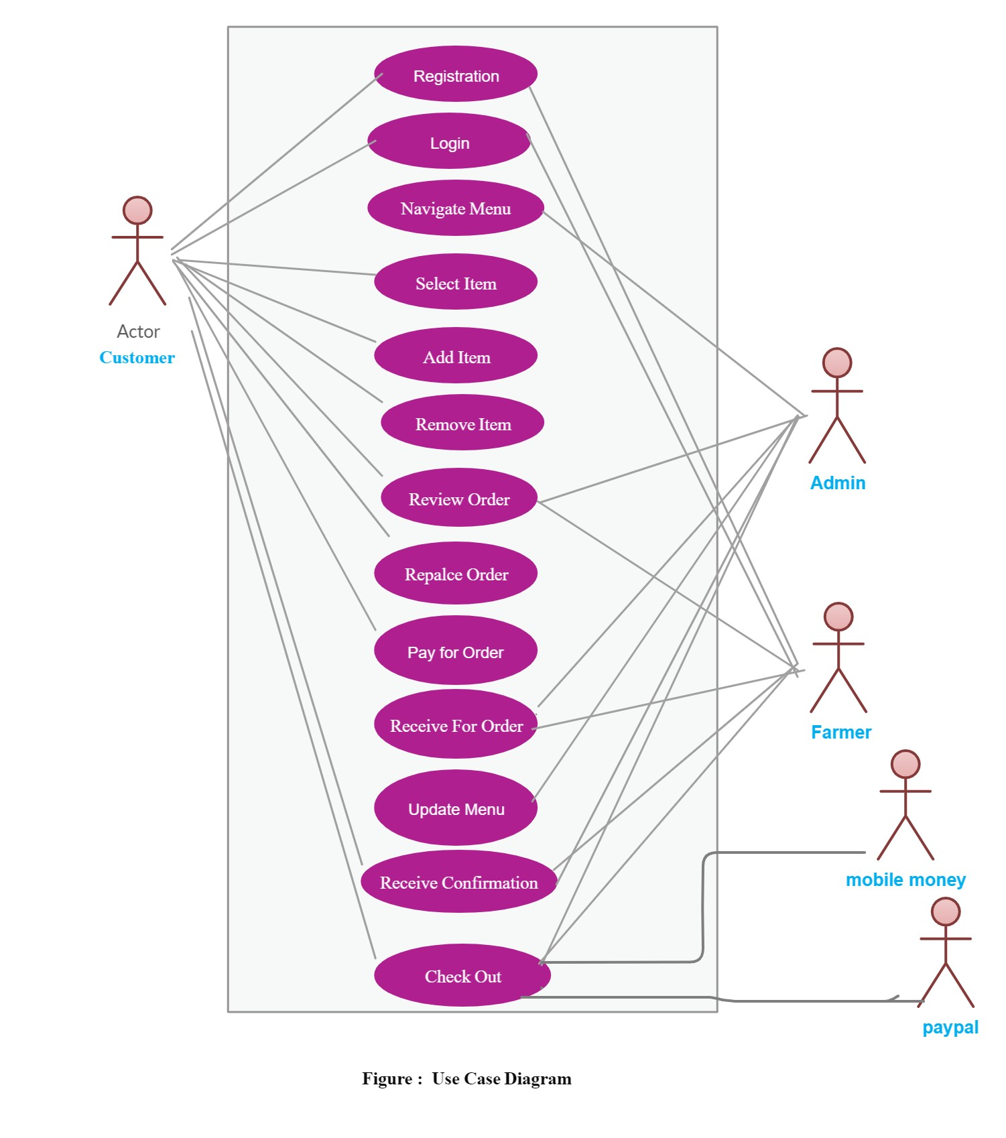

Figure 3: shows a use case diagram of an online livestock management system

**4.2.1.3 State Diagram.**

A state diagram is a diagram used to describe the behavior of a system considering all the possible states of an object when an event occurs. This behavior is represented and analyzed in a series of events that occur in one or more possible states.

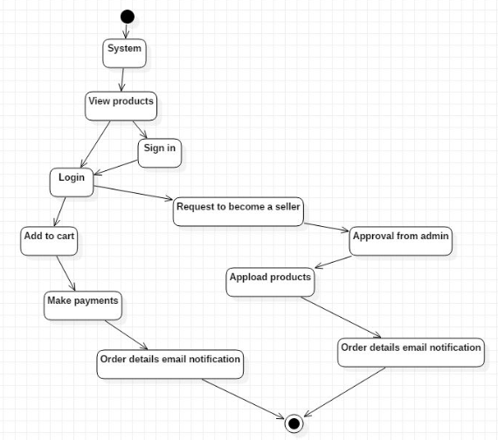

Figure 4: A state diagram for a livestock market system.

## 4.2.1.4 Sequence diagram.

A sequence diagram shows object interactions arranged in time sequence. It depicts the objects and classes involved in the scenario and the sequence of messages exchanged between the objects needed to carry out the functionality of the scenario. Sequence diagrams are typically associated with use case realizations in the [Logical View](https://en.wikipedia.org/wiki/4%2B1_architectural_view_model) of the system under development. Sequence diagrams are sometimes called event diagrams or event scenarios.

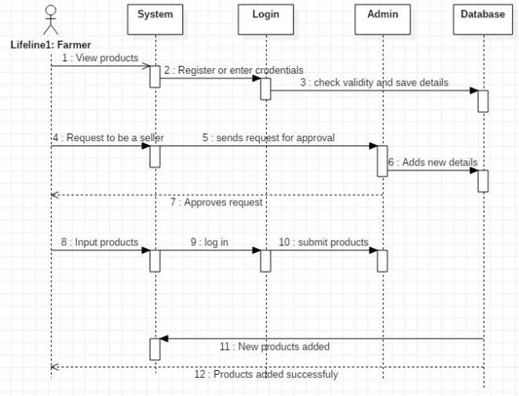

Figure 5: Shows a sequence diagram for a livestock market system

## 4.2.1.5 Database Design.

Database design is the organization of data according to a database model. The designer determines what data must be stored and how the data elements interrelate. With this information, they can begin to fit the data to the database model. Database design involves classifying data and identifying interrelationships. Here we designed the following database Famers, Product, Orders, OrderDetails, Customers, Category and Payment as illustrated below.

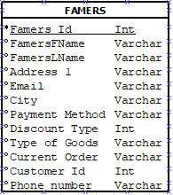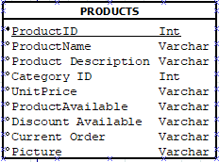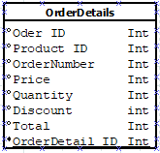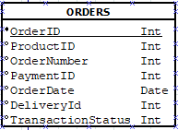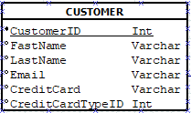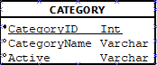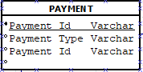

Figure 6: shows database table designs of an online livestock market system

## 4.2.1.6 Entity Relationship Diagram

Entity relationship diagrams are used in software engineering during the planning stages of the software project. They help us to identify different system elements and their relationships with each other and we it used as the basis for data flow diagrams or DFD's as they are commonly known. The main entities in our ERD diagram are famers, products, category, customer, order details and payment.

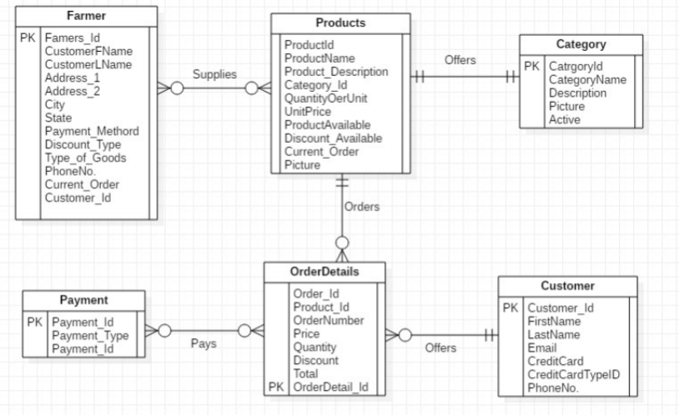

Figure 7: shows ERD diagram for an online livestock market system

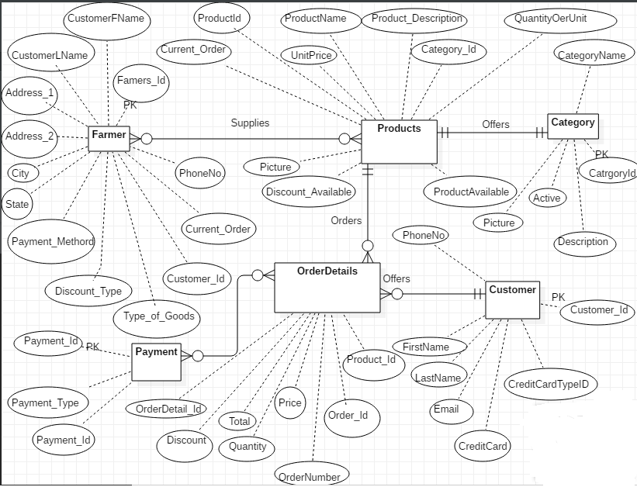

Figure 8: shows extended ERD diagram for an online livestock market system

## Data Flow Diagram (DFD).

Data flow diagram is graphical representation of flow of data in an information system. It is capable of depicting incoming data flow, outgoing data flow and stored data. The DFD does not mention anything about how data flows through the system.

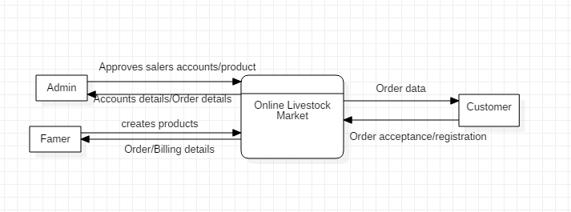

Figure 9; shows the DFD Level 0

**DFD Level 1**

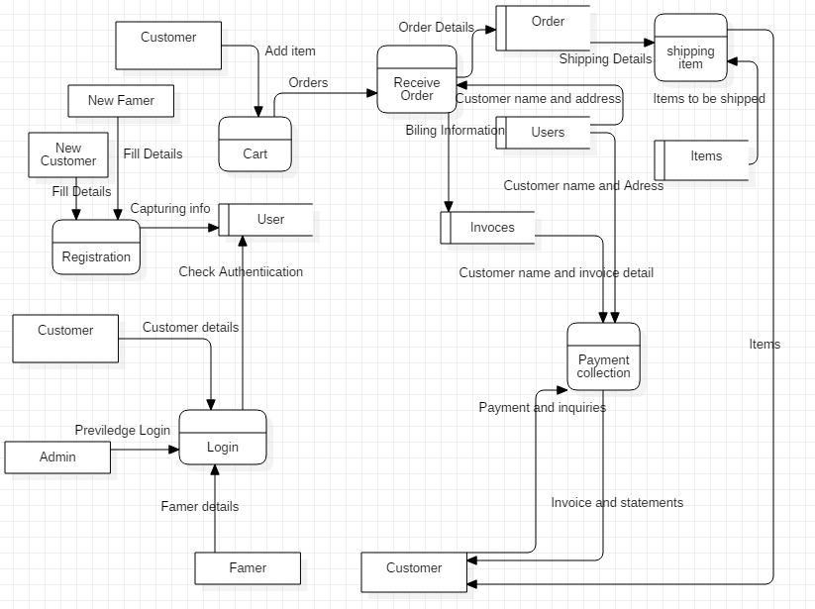

Figure 10; SHOWS DFD LEVEL 1

DFD LEVEL 2

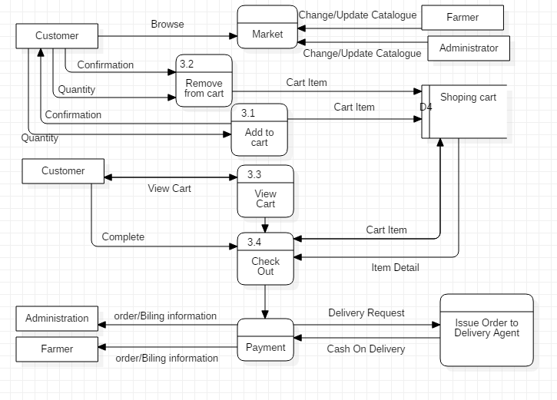

Figure 11: Shows Data Flow Diagram Level 2 of a livestock management system

## 4.2.1.8 Object class diagram.

A static object diagram is an instance of a class diagram; it shows a snapshot of the detailed state of a system at a point in time." It also stated that object diagram is "a class diagram with objects and no classes”. Object diagram overview - instance specifications, value specifications, slots, and links.

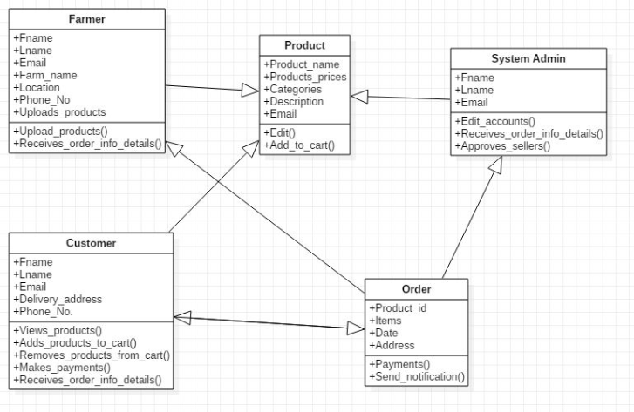

Figure 12:Shows the Object Class diagram for a livestock market system

## 4.2.1.9 Interface Design.

This is the design of user interface for a website with the focus on maximizing usability and user experience. We designed interfaces for our online livestock market system and our focus was maximizing efficiency, responsiveness and aesthetics to foster a good user experience. An interface is a point of interaction between the user and the hardware and/or software they are using. The goal of user interface design is to make the user's interaction as simple and efficient as possible.

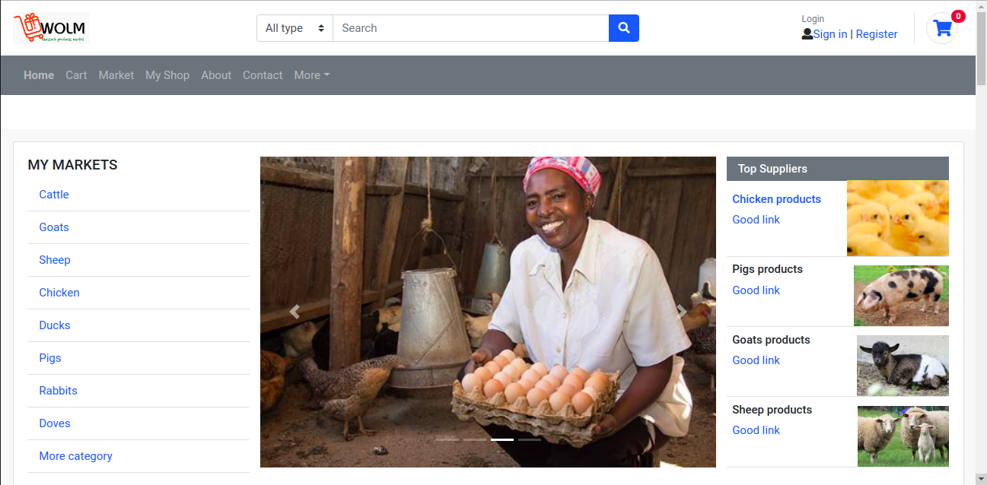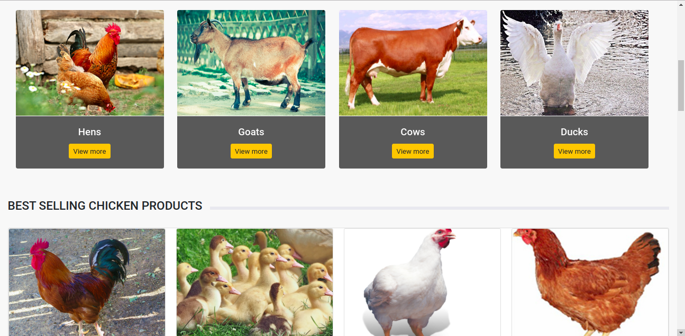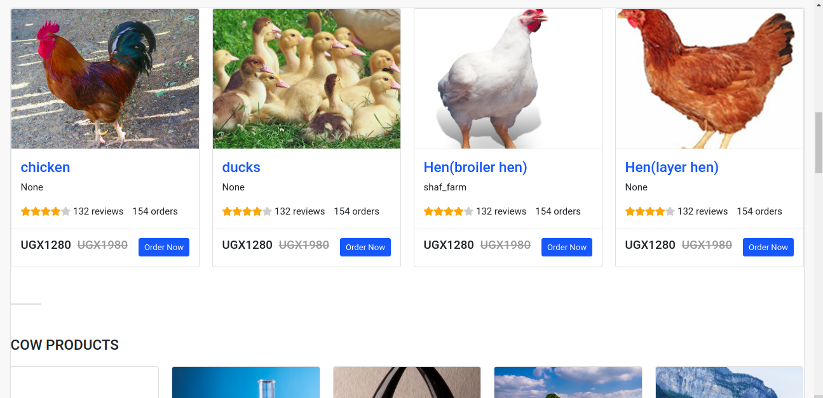

Figure 13 shows home page interface

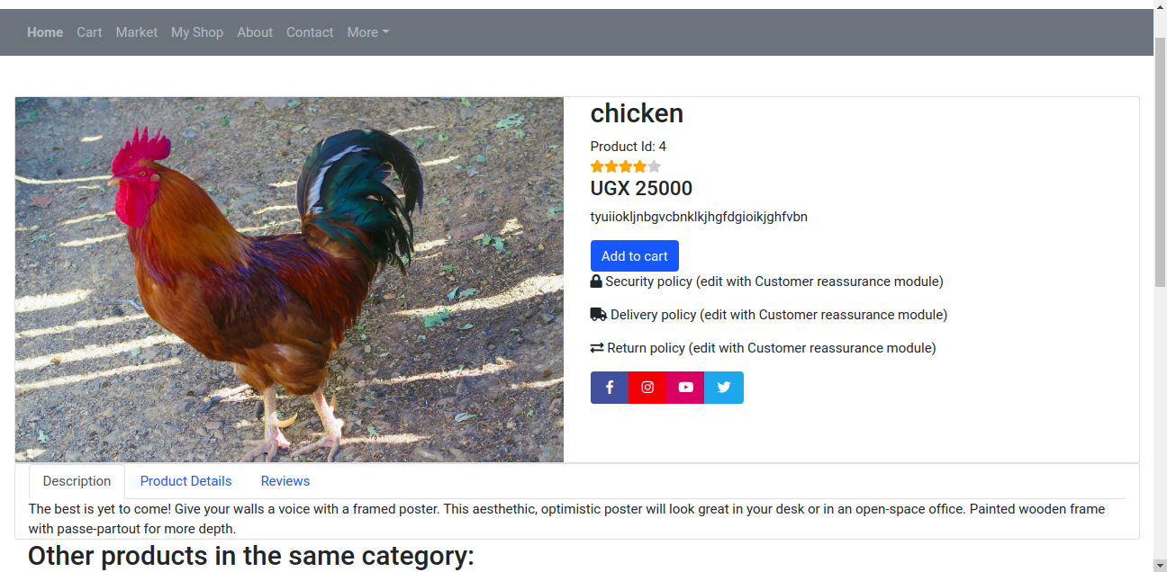

Figure 14 shows product page interface

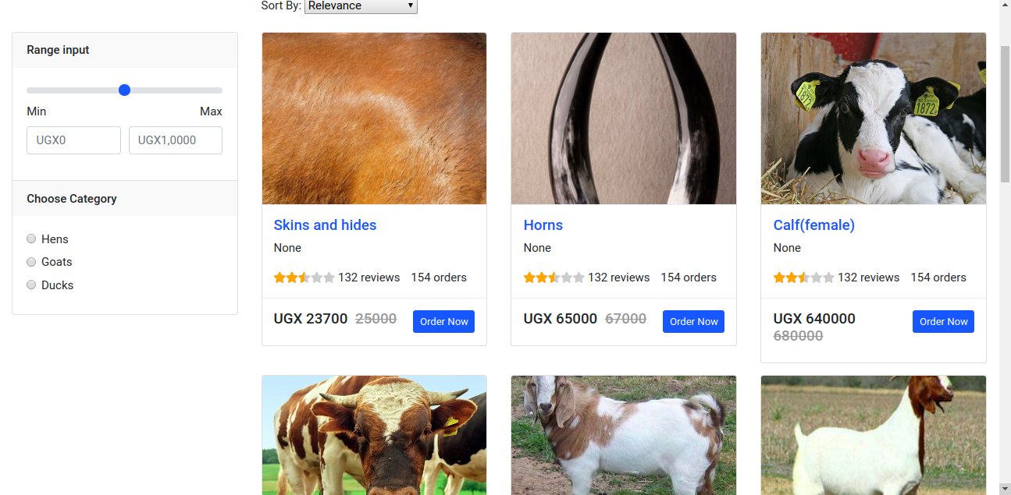

Figure 15 shows market place page interface

## 4.3 System Implementation

Systems implementation is the process of defining how the information system should be built that is to say physical system design, ensuring that the information system is operational and used, ensuring that the information system meets quality standard (that is to say, quality assurance). The system was implemented using parallel approach where by the new system is used alongside the old system in parallel. It ensures that the information system is operational while meeting all the stated quality standards. The old system will be stopped when the new system has proven to work well.

## CHAPTER FIVE: SYSTEM TESTING AND EVALUATION

## 5.1 Introduction

This chapter describes the different testing method we used to validate the online livestock market System**.**

## 5.2 System Testing.

Testing is intended to show that a program does what it is intended to do and to discover program defects before it is put into use

Testing was done after the system was put in place. This was done in two ways namely Unit Testing and integration testing. In the case of errors, debugging was done. Using detailed testing strategies, a test plan was carried out on each module.

**Unit Testing**

Unit testing was carried out on individual modules of the system to ensure that they are fully functional units. The team did this by examining each unit, for example the system administrator page, customer’s page, farmer’s page. It was checked to ensure that it functions as required as well as storing the data in the database. The success of each individual unit gave us the go ahead to carryout integration testing. All identified errors were debugged and correct results were achieved.

**Integration Testing**

We carried out integration testing after different modules had been put together to make a complete system. Integration was aimed at ensuring that modules are compatible and they can be integrated to form a complete working system. For example we tested to ensure that a farmer can be able to upload his/her products for sale and also the buyer can also see the available products for sale. Errors were debugged in cases were one page was no linking to another.

## 5.2.1 System Verification.

System verification is the process of determining whether or not a system fulfils the requirements or specifications established for it (MITRE, 2014). In other words System Verification is a set of actions used to check the correctness of a system.

Verification of this system was done by testing whether a customer can be able to search a particular product he/she wants to buy.

## 5.2.2 System Validation.

System validation is the assessment of a delivered system to meet operational need in the most realistic environment achievable (MITRE, 2014).  System Validation is a set of actions used to check the compliance of a system

Validation of the system was very important and this was done by comparing whether the log in password and usernames are the correct existing credentials in the database of the system administrator. That is can a user log in using wrong password into the system? Or does clicking save/submit button store data in the database?

Python was used to validate user input and the respective input. For example the system does not accept blank field, dialog box after any action is completed such as deleting.

## 5.3 System Evaluation.

System evaluation is the process of assessing the performance of a complete system to discover how it is likely to perform in live market conditions.

The intent of system evaluation is to collect information about the system, the functions of the system, the expected user activities, the system architecture, and any other details that are helpful in guiding performance testing to achieve the specific needs of the project.

We presented to a set of university panelists about user interface functionality of the system, system functions and the interaction that occur in the system.

## CHAPTER SIX: ETHICAL CONSIDERATIONS AND LIMITATIONS

## 6.1 Introduction.

This chapter covers the ethical issues that were considered before, during and after the system development and also the issues that limited and hindered the development of the Student Follow-up System.

## 6.2 Ethical Considerations

## 6.2.1 Human ethical consideration.

The study focused on human beings and therefore was ethically responsible for protecting the rights and welfare of the subjects that participated (McMillan & Schumacher, 2001). Human ethical considerations included;

1. Voluntary participation of respondents in the research. Participants had the right to withdraw from the study at any stage if they wished to do so.
2. The participants participated on the basis of the informed consent (the respondents were made aware of the reason as to why they were being interviewed).
3. Acceptable language was used in the formulation of questionnaires and during the interviews.
4. Privacy and anonymity of respondents was of paramount importance.
5. Acknowledgement of works of other authors used in any part of the for example by citing and referencing them.

## 6.2.2 System ethical considerations.

#### a) Data Security

Any sensitive information entered in the system is highly protected by the administrator and the system administrator reserves the permissions and also controls what different users can access.

Other encryption algorithms can be used to secure any transmitted information among the various entities of the model of the system.

#### b) Database Security

At the database level, the database management system requires the creation of user and various roles assigned to them. Strong password policies are enforced at the database level to reduce the possibility of intrusion and malicious damage of data. Sensitive data fields, such as stakeholder passwords, have to be encrypted in the database

## Limitations of the project.

**Attrition rate;** this is the rate at which participants have missing data at one or more points (dumville, 2006).

It was a limitation during data collection where by four (4) respondents didn’t not fill the questionnaires. However, we overcame this challenge using interviewing method since interviews cover a wide range of areas.

**Time;** the team had to work under pressure in order to accomplish the project due to limited duration attached to the project.

## CHAPTER SEVEN: CONCLUSION AND RECOMMENDATION

## 7.1 Introduction

This chapter explains the conclusions and recommendations made on the design and implementation of the system.

## 7.2 Conclusions

Conclusively,the successful design and implementation of an online livestock market will enable farmers to market their livestock products and will also provide buyers with easy access to livestock products and this will bust Agri-Business in West Nile region particularly Arua and will also improve the standards of leaving of people.

**7.3.Discussion and Findings.**

Basing on the analyzed statistics we found out that 75% of the livestock farmers were incuring high transportation costs for their products to and from the market this is evidenced by transportation cost graph in appendex 2.

We also found out that more than 62% of the livestock farmers have smart phone so this could enable them access our system.This is evidenced by smart graph in appendex 2.

We also found out that most of the livestockfarmers 52% in Arua Westnile have daily access to internet evidenced by access to internet graph in appendix2.

We also found out that farmers who markert their livestock products daily are more compared to those who market livestock products rarely this is evidenced by Operation graph in appendex 2.

## 7.4 Recommendations

Capstone project should be given more time to reduce on pressure put on students because three and half months are too small to accompish tne project.

## REFERENCES

(*Livestock Development Needs Assessment Report for*, n.d.)*Livestock Development Needs Assessment Report for*. (n.d.).

Christoph, H., & Nebojša, N. (2014 (61)). farm operations in Tennessee. *Vol. 6*, 441-453.

Fountas, S., Blackmore, S., Ess, D., Hawkins, S., Blumhoff, G., Lowenberg-Deboer, J., & Sorensen, C. (2005). Precision Agriculture. *Farmer experience with precision agriculture in Denmark and the US Eastern Corn Belt, vi*, 121-141.

Glauben, T., Tietje, H., & Weiss, C. (2006). Exploring regional differences in farm exit rates in Western Germany, Jahrbuch für Regional wissenschaft. In *Agriculture on the move* (Vol. 26, pp. 103-118). Grubb, J. (2010). A low cost automated livestock tracking system. *Livestock system*. Retrieved 2010

James, H., & McMillan. (1996). fundamentals for the consumer. In *Education research.*

John, Z. (2017, April 24). What Is the Meaning of Sample Size. Retrieved 2017, from https://sciencing.com/meaning-sample-size-5988804.html

Malcolm, B. (2004b). Where’s the economics? The core discipline of farm management has gone missing. *The Australian Journal of Agricultural and Resource Economics, 48*, 395-417.

*Ministry of Agriculture*. (2013). Retrieved from Ministry of Agriculture:

http://www.gou.go.ug/content/agriculture

Muhammad, S., Tegegne, F., & Ekanem, E. (2004). Factors contributing to success of small 452.

Ronald. (2017, September 16). Cattle management system at Bego farm. (Charity, Interviewer) Arua.

Sørensen, C., & Bochtis, D. (2010). *Conceptual model of fleet management in agriculture* (Vol. vol. 105).

Thomas Metz, M. D. (1999). *Livestock Information Management System.* Nairobi: International Livestock Research Institute.

## Appendix I - Research Instrument

**A QUESTIONNAIRE** **LIVESTOCK AND LIVESTOCK PRODUCTS MARKET SURVEY.**

All information received on this form will be treated as strictly confidential. The aim of this questionnaire is to analyze the current livestock market

Please you are kindly requested to tick the appropriate answer to the questions below thanks.



1. **G**ender?

Female Male

1. Do you market your livestock and livestock products?

Yes No

1. How far the market is you sell your products from your farm? Very near Near Far Very far

1. How often does this market take place?

Daily Weekly After 2 weeks monthly

If any other specify……………………………………………

1. What time does the market open?

Before 7:00am between7:00amand 8:00am after 8:00am

1. What time does the market close?

Before 7:00pm between7:00pmand 8:00pm after 8:00pm

1. What time do you leave the farm to go to the market?

Very early early

Any other specify……………………………………………

|  |
| --- |
|  |

1. What time do you leave the market to go back home? Before 7:00pm between7:00pm and 8:00pm

Any other specify……………………………………………

1. Do you pay some amount of money to sell your products in this market?

Yes No

1. Do you pay some amount of money for transporting your products to and from the market?

Yes No

1. Do you have access to a smart phone?

Yes No

1. How often do you access the internet?

Daily Weekly monthly Never Other…………

1. Have you ever used online marketing?

Yes No

1. How do you currently market your livestock and livestock products?

Physical Online Other…………………….

1. On a good business day, how many customers do you normally have?

Very few Few Moderate Many very many

1. Do you have access to information about modern livestock farming methods?

Yes No

1. Do you have access to information about vaccination and diseases prevention methods?

Yes No

1. Do you have access to livestock market information?

Yes No

1. How accessible is crossbreeding information to you?

|  |
| --- |
|  |

Not-accessible Moderately-accessible Yes not sure Easily accessible

No

1. Would you like to access all the above information?

Yes

1. Do you use online marketing?

Yes No

1. If yes, how effective is it?

Not effective somehow effective effective

Very effective

23. Which animals do you rare?

Goats cows poultry sheep pigs

Any other specify………………………………….

**Thanks For Your Time**

Appendix 2

